Project Description
ORIE 3120: Practical Tools for Operations Research, Machine Learning and Data Science
Spring 2026

Overview
The class will culminate in a final project in which you use the data visualization and data analysis skills you’ve learned to analyze an interesting dataset. This project will give students experience in the kind of work that a data scientist might perform in industry, or at a government or nonprofit agency. These projects will be completed in teams of 3-4 students.
In these project milestones, you will be required to use data and tools from the class to explore and answer questions that you will identify. For each milestone, you will provide written reports that should clearly explain to others what you discovered, how you discovered it, and why it is important.

Assignment Due Dates & Grading Breakdown
- Self-grouping: Tuesday Feb 3 [1 point]
- Team formation Google form: Thu Feb 26 [1 point]
- Requests to use a dataset not on the pre-approved list: no deadline, but we strongly suggest making these by Sun Mar 1 [not graded]
- Team meeting with TA: Complete before project milestone 1 is due [1 point]
- Project milestone 1: Mon Mar 9 [40 points]
  - Team report [32 points, or 80% over the project total]
  - Individual components: personal reflection, time-tracking sheet, & teammate evaluations [8 points, or 20% of the project total]
- Outside-team feedback on project milestone 1 team reports: Wed Mar 18 [2 points]
- Project milestone 2: Sat May 9 at noon [40 points]. Note the unusual time of day. This deadline is mandated by the registrar in their final exam & deliverable schedule.
  - Team report [32 points]
  - Individual components: personal reflection, time-tracking sheet, teammate evaluations [8 points]
- Outside-team feedback on project milestone 2 team reports: Monday May 11 at 11:59pm [2 points]

Assignment Descriptions
There will be six assignments, whose due dates are listed above.
Self-grouping: This will be graded for completion.
Team Formation Google Form: Your team will submit a Google form that is intended to help your team start talking.
This form will be graded for completion but not for content. We may come back to teams to ask for more detail or changes if their forms don’t reflect robust alignment and discussion between team members. Also, if it is clear that a team member didn’t participate in the team formation assignment, the teaching staff will set up a discussion with that team to help them achieve better alignment.
Project Milestone 1: This will have both a team component and 3 individual components detailed below.
Team component: You will describe your dataset, discuss a few interesting and important questions that you wish to answer using the dataset, present at least three different visualizations of the data, and discuss how these visualizations give insight into the questions you seek to answer. The report will be submitted as a pdf of maximum 4 pages.
Individual components:
- A personal reflection, max ½ page. It should describe how you contributed technically to the project and describe how you helped keep team dynamics strong. It should also answer these questions: What challenges did you face? How did you overcome them? What did you learn? Go beyond what is in the team report.
- Filling out your individual entries in the time-tracking sheet that your team submitted with its team formation google form.
- Providing a teammate evaluation.
Project Milestone 2 (Final Report): This will have both a team component and the same 3 individual components as Project Milestone 1.
Team component: You will use at least three data analysis methods learned in class to better answer the questions posed above about your dataset. The questions answered may be descriptive (what factors lead to high COVID-19 infection counts in US counties?), predictive (which countries will have more than 10 COVID-19 infections per 100K of population reported per week by September 2021?), or prescriptive (how should COVAX doses of COVID-19 vaccine be distributed to minimize loss of life?). Data analysis tools that will be available for use in the class include linear regression, testing the assumptions of linear regression, logistic regression, selecting a statistical model for a prediction task based on train/test splits, optimization via random search, causality, simulation, and stochastic models. You may also use other tools to achieve your goal, but they must be clearly explained. The report will be submitted as a pdf of maximum 8 pages.
Individual components:
- Personal reflection, max 1 page, covering the same questions as in Project Milestone 1 but updated to include your new experiences. You are allowed to re-use content but a desire to do so is usually a sign that your personal reflection is of low quality. Someone who is working hard on the project and trying to do their best will meet a lot of new challenges and learn a lot between Project Milestone 1 and Project Milestone 2 and your personal reflection should reflect this.
- Updating your individual entries in the time-tracking sheet.
- Updating your teammate evaluation.
Outside-Team Peer Feedback: Students will also be required to provide peer feedback on both the project milestone and final report for reports from other teams. Peer feedback will be graded for appropriateness and thoughtfulness. Peer feedback will be considered by course instructors when assigning final grades for project milestones.

Teams
Due to (1) course logistics that prevent free choice for all students, (2) the need for fairness across students, (3) evidence that diverse teams do higher quality work, (4) a goal of training students to work with many different kinds of people (not just their friends), (5) and the desire to provide realistic and effective training for internships in data science and related fields, teams will be assigned by the instructional staff using a teamwork tool called CATME. To emphasize, students will not be able to pick their own teams.

Grading
The overall grade for the project will be computed via a weighted average using the point totals listed above under Assignment Due Dates & Grading Breakdown.
Slip days may be used for the peer reviews.
Slip days may not be used for the project milestone (including the individual components) and project final report.

Project Milestone 1 & 2 Team Component
Grades for the team component of the first milestone and project final report will be based on their quality, as judged by the teaching team. The teaching team may choose to consider feedback from peer grading. In most situations, all students on a team will earn the same grade for each team component. (It is expected that grades on the individual component will differ across individuals in the same team.)
However, in exceptional situations, it may arise that a student does very little work compared to their teammates. In this situation, that student’s score on the team component may be less than their teammates (and such a student is likely to earn zero points on the individual components). To support such determinations, the teaming staff will assess the individual components submitted. They may also examine individual contributions via the Google drive / github repository included with your team formation assignment, and, if necessary, conversations with team members. To help with this, teams are strongly encouraged to use Google docs, github, google colab, or other tools that track an individual's contribution history.

Project Milestone 1 & 2 Individual Components
Each milestone will have 3 individual components:
- A personal reflection, which is ½ page for project milestone 1 and 1 page for project milestone 2
- Filling out the time-tracking sheet that you provided in the project formation google doc
- Filling out a peer evaluation form in this template:
ORIE 3120 Template for Personal Reflection and Teammate Evaluation
The personal reflection should include:
- Describe how you contributed technically to the project.
- Describe how you helped keep team dynamics strong
- What challenges did you face? How did you overcome them? What did you learn? Go beyond what is in the team report.

Other assignments
Peer reviews: See the example peer review for a high-quality example of a peer review that would receive full credit. Points will be divided equally across the assigned peer reviews.
Self-grouping: Points are awarded for completing the group formulation by the deadline.

Datasets
Selecting a dataset is tricky. In past years, teams have gotten themselves in trouble by selecting a dataset that doesn’t support doing interesting data science. To help mitigate this, we have a pre-approved list of datasets below (anything in this section of this google doc is pre-approved). In addition, you can request approval of a dataset to use for your project as described below.
If your dataset isn’t working for you, you can switch datasets. But if you do this, your previous work and thinking will be lost. Sometimes pivoting is smart and sometimes it isn’t. Do your best to be smart. When you select a dataset, it’s best to do some quick work to assess whether it’s going to work, so that you can find out quickly if it isn’t going to work, giving you time to switch. This is called “failing fast”.

What makes a good dataset?
- Your primary goal in the project is to answer interesting questions. Your dataset must allow you to do this. If it doesn’t, change your dataset.
- If your dataset is small, it’s going to be harder to do interesting work. If it has less than 1000 rows, you probably shouldn’t use it. If it has less than 10 columns, then it’s less likely that there is something interesting in those columns, and if there isn’t anything interesting, then you shouldn’t use it. Ideally, you’d have 100K rows or more — this makes it much easier to do interesting analysis.
- Think about who your question is interesting to. There should be someone who cares about the answer.
- Be careful about causality. Most questions are causal but most datasets do not allow answering causal questions (at least, not very easily). You will learn about causality during the machine learning part of the course. You will also learn about ways to answer causal questions with data (e.g., through controlling for confounders).
- The dataset needs to be credible — i.e., you need to believe that the values measured have a basis in reality. Credibility can come from multiple sources, but one sign of a lack of credibility is that you don’t understand what is being measured.
- Do you need to do a lot of cleaning to be able to use the data? If so, that’s dangerous because it might not work.
- Is the dataset complete or is there a lot of missing data?

Here’s an example to illustrate what can go wrong with causality:
- Consider this question: “Would changing a stop sign to a traffic light cause a reduction in traffic accidents?” This is a causal question.
- Suppose your dataset records traffic accidents, with a label for whether it was near a stop sign, and whether it was near a traffic light.
- You then look at the number of accidents that were near stop signs, and the number that were near traffic lights. Suppose you see that the number that were near traffic lights was lower.
- On its own, this does not mean that traffic lights reduce accidents. Instead, it could be that more cars travel through intersections with traffic lights than stop signs. It could also mean that cities install traffic lights at intersections that are more dangerous.

Pre-approved datasets
- Traffic accidents in the US.
- Police Use of Force. There are a number of datasets studying the use of force by police and broader questions about the relationship between police activity, crime and race.
  - Mapping Police Violence
  - Police Violence and Racial Equity, Kaggle
  - Police Data Initiative
  - Data.World
- UNHCR Refugee Migration. This data set records refugee migrations over 60 years, across hundreds of countries.
- COVID. This dataset contains infections and hospitalizations by date, US state, and country. This is also interesting when merged with US Census data.
- New York City Taxi Dataset contains taxi trips and trips on Uber / Lyft / other vehicle-for-hire platforms from 2009 to 2020. This can be combined with data from the Metropolitan Transit Authority on how many people use the subway and bus system and subway delays.
- Supermarket Purchases Dataset contains information about the audience segment, location, quantity, items, profit/loss, etc. of various transactions from a large, chain supermarket.
- Engineering ads dataset. (Warning — working with this dataset will likely require going beyond the course to do machine learning with text data.)
- Expedia Hotel (kaggle.com)
- Product Positioning for Sales (kaggle.com) (Warning – synthetic dataset, analysis will need to focus more on developing useful methods for determining which features are the most important in this dataset. Because the dataset is synthetically generated, a stakeholder probably wouldn’t care about specific insights about the data itself. Instead, they would be looking for evidence that a particular class of data science methods are ABLE to extract actionable insights. If they believed that the methods were valuable, they could then apply the methods to real but proprietary data from their own company. It is ok to conduct your PM1 and PM2 analysis as if the dataset were real.)
- 120 years of Olympic history: athletes and results
- Death Due to Air Pollution
- National Center for Educational Statistics
- Where it Pays to Attend College
- Formula 1 Dataset (1950 - 2023)
- Inside Airbnb: Get the Data

Selecting and getting approval for your own dataset
If your team wants to choose its own dataset, you can request approval for your own dataset. To do this, follow the advice below about how to select a good dataset. Then make an Ed post to request approval. Include the dataset, information about the dataset size, and what questions you think would be interesting to answer using this dataset. The teaching team will then take a look and let you know if this would make a good project.

If you are going to request using your own dataset, we strongly recommend making this request by March 1, so that the teaching team has time to give you feedback and you have time to react.

There are at least two good ways to find datasets:
- Browse around the resources below until you find something interesting. Then think of questions that would be interesting to answer using this dataset. Sometimes (especially on Kaggle) the dataset author will suggest questions.
- Think of a question or topic that you are interested in, and then search for datasets that will let you answer it. You might find that you can’t answer your original question, but that you can answer another related question.

Can you join together two different datasets? For example, suppose you have a dataset on Traffic accidents in the US and you want to join it to another dataset with detailed weather or traffic volume information by using the timestamp for when the accident occurred. Can you do this?

You can, but you need to get approval for this. It’s really hard to do well, and most ORIE 3120 teams that try fail at this. Common problems include datasets that use different ways of describing the same thing, cover different time periods, or that don’t provide an easy way to relate records across datasets. If you request approval, we are going to want to see some evidence that you are going to succeed.

Places to Search for Datasets
If you want to look for your own dataset, here are some resources.
- Kaggle has a great selection of very interesting datasets. This is a good place to start. You can go to the dataset page (screenshot below) and either browse until you find something, click on one of the tags, or search for something you are interested in.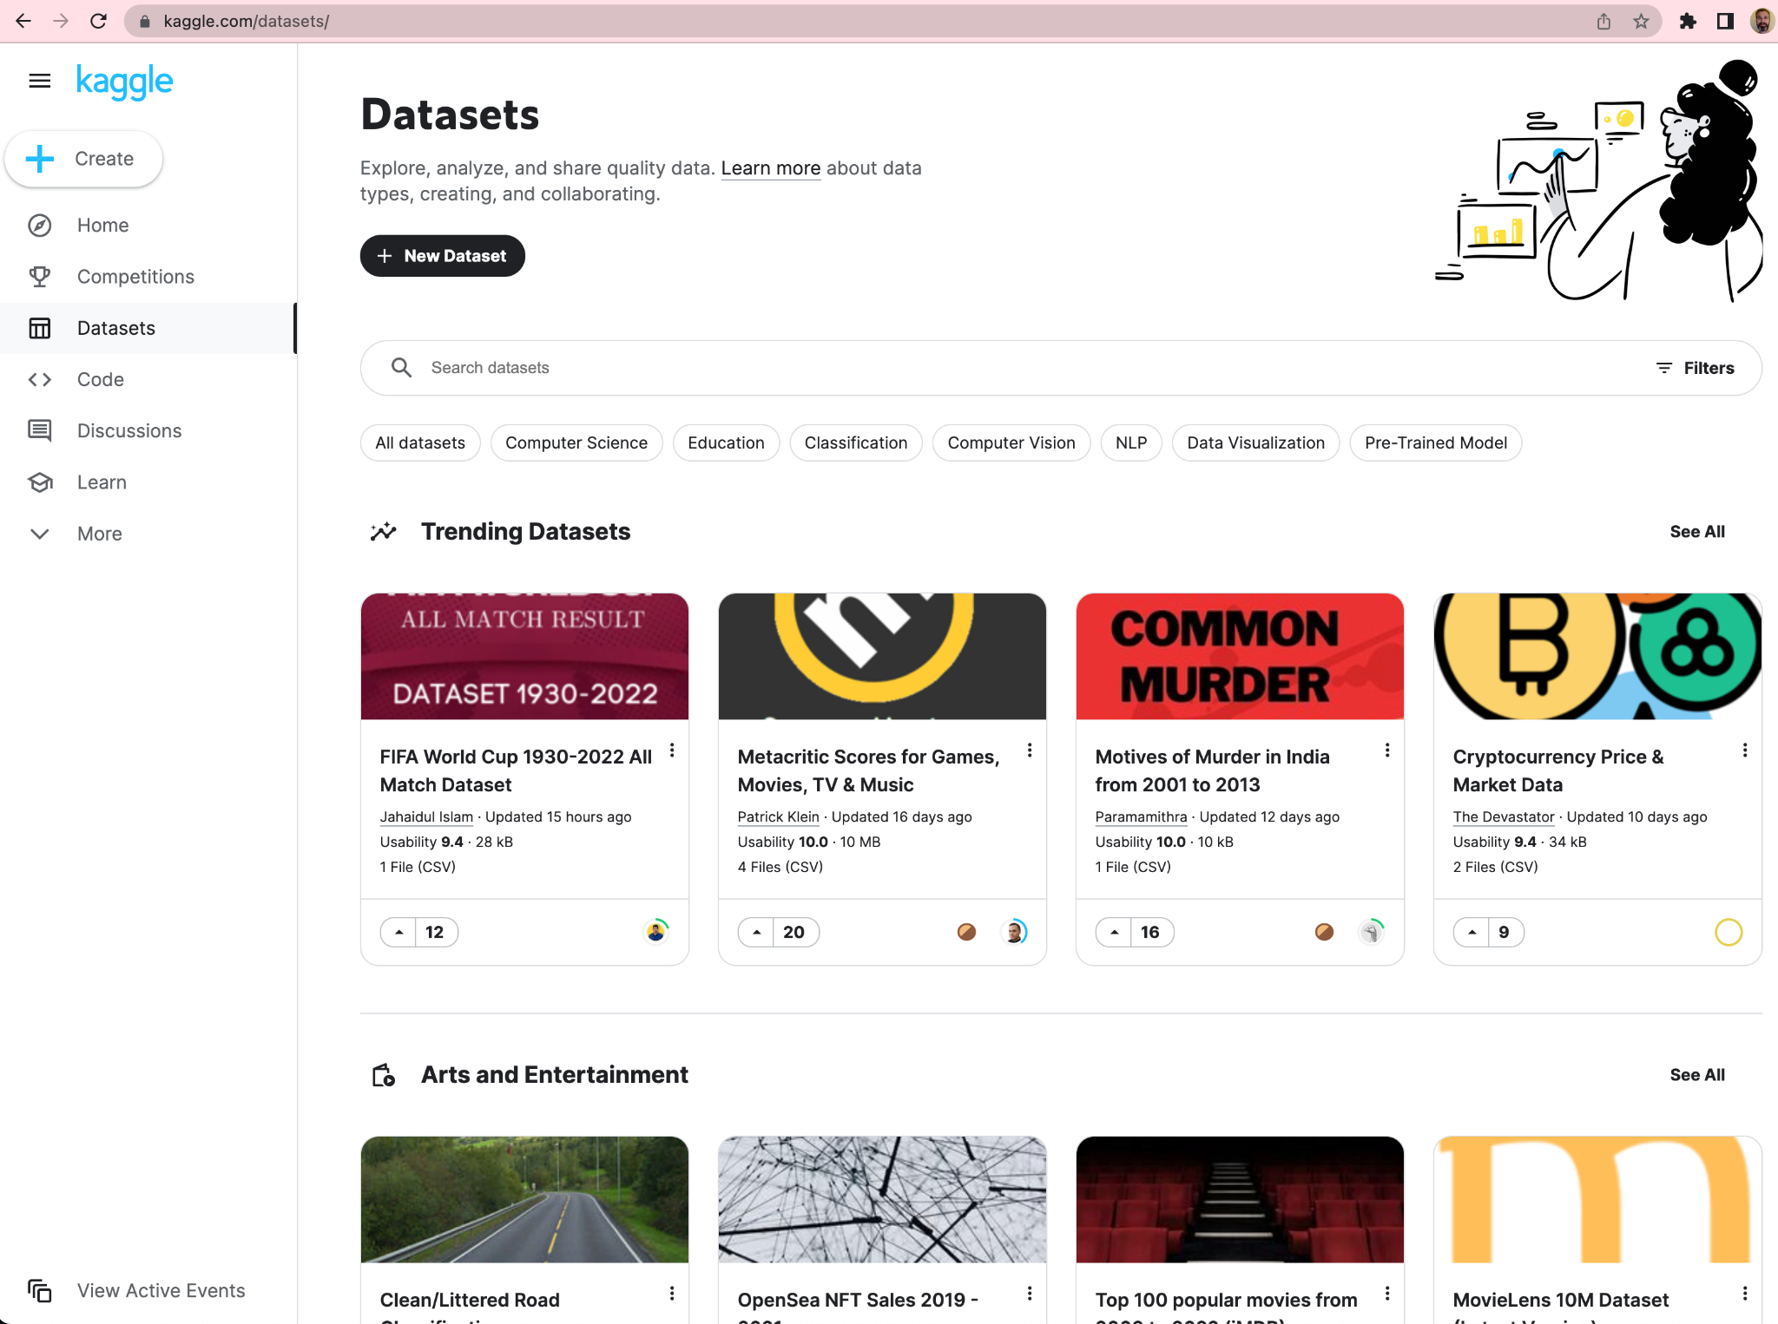
- Data.world also has many different datasets on many different topics. Browse the datasets or search for a topic your team finds interesting.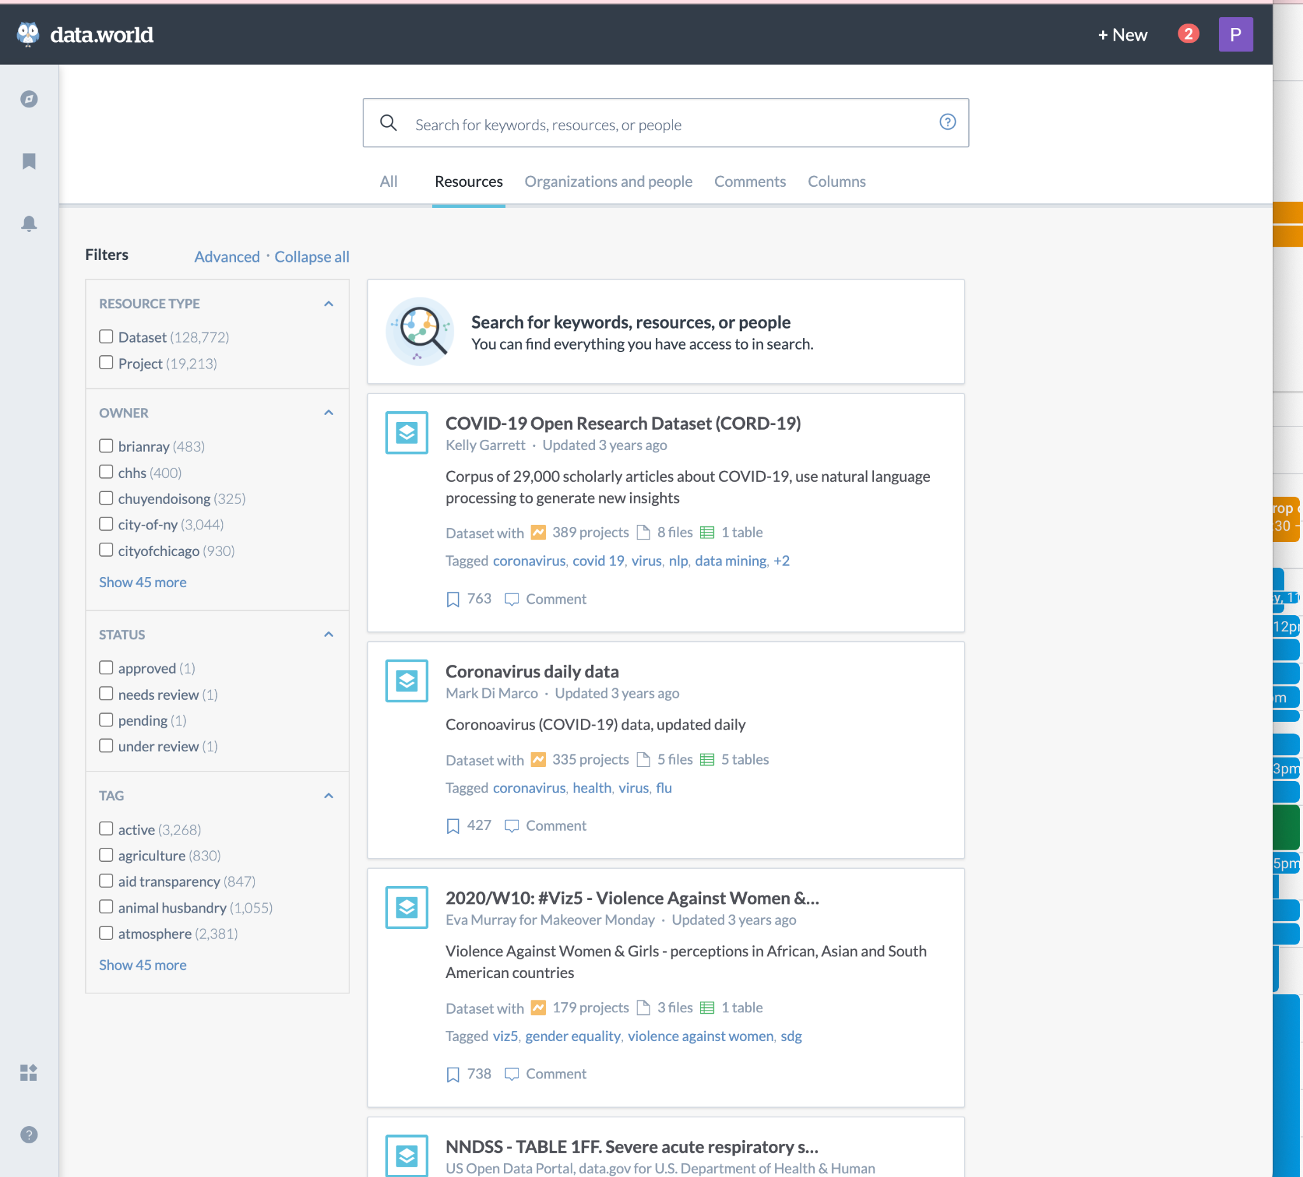
- OpenICPSR is a repository of datasets in the social and health sciences
- openAfrica is a large list of free datasets pertaining to the African continent
- The American Economic Association maintains a list of datasets relevant to economics
- Many governments provide open datasets. Here is a selection of data from the US federal government, New York State, and from Africa. Other states and countries also provide open datasets.
  - The US Census is a fantastic resource and includes fine-grained demographic information broken out by location. It can often be joined against other datasets.
  - The US Center for Disease Control has many datasets related to human health
  - The Bureau of Labor Statistics has economic statistics and other statistics about human behavior. For example, The American Time Use Survey (ATUS) “measures the amount of time people spend doing various activities, such as paid work, childcare, volunteering, and socializing”.
  - New York State has datasets about things that go on in the state
  - New York City’s Metropolitan Transit Authority
- Many academic papers release data. You can search on google scholar for papers about an area that you are interested in and then see whether they have public data that you can use. For example, this dataset about drought and other anomalies in agricultural production [Anomaly Hotspots of Agricultural Production] is part of the “replication package” of this academic paper [Jack & Suri 2014]. A replication package is a set of files that readers can use to replicate the results in an academic paper. Some journals require replication packages. One such journal is the American Economic Review.
- Open Street Maps is another good resource if you want to join against spatial data.

Instructions for Uploading Milestone 1
To submit the project report for milestone 1, upload your team pdf to the Canvas Assignment “Project Milestone 1 Team Report”. Only one submission is needed per team.
To submit your personal reflection and team evaluation:
- Follow the instructions in this google doc to create a google doc or word doc that has your personal reflection and team evaluation:
ORIE 3120 Template for Personal Reflection and Teammate Evaluation
- Then export as a pdf and upload to GradeScope.

To submit milestone 2, we plan to follow a similar approach to milestone 1 —

Rubric for Project Milestone 1
Recall the instructions for project milestone 1 from above, copied here for reference: You will describe your dataset, discuss a few interesting and important questions that you wish to answer using the dataset, present at least three different visualizations of the data, and discuss how these visualizations give insight into the questions you seek to answer. The report will be submitted as a pdf of maximum 4 pages.
With this in mind, the project milestone will be graded by the TAs based on the following criteria:
- Dataset:
  - Is the dataset clearly described? [10 points]
  - Does the project discuss at least two questions? Does it seem like they can be answered using the dataset? [15 points]
- For each visualization (if there are more than 3, we’ll take the 3 best ones):
  - Does it give insight into at least one question? [5 points]
  - Is the visualization and the way in which it gives insight clearly discussed? [10 points]
Peer reviewers will be asked to answer the following questions in their reviews:
- What is the project about? [at least 3 sentences]
- What questions does the project propose to answer? [at least 2 sentences]
- Is the question interesting and important? Why? Who will be most interested in the answer to this question? How will knowing the answer improve their lives, e.g., will it improve the quality of a decision they need to make? [at least 3 sentences]
- Is the team well-positioned to be able to answer the questions using the dataset? What are some challenges they may face? [at least 2 sentences]
- The project should contain at least 3 visualizations. If there are more than 3, the reviewer will choose 3 of them. For each one, they will answer:
  - What is the visualization showing? [at least 1 sentence]
  - What insight does this visualization give into the question(s)? [at least 1 sentence]
  - Regarding the visualization and its discussion:
    - What is good about it? [at least 1 sentence]
    - What could be improved? [at least 1 sentence]

Example Peer Review
To illustrate what we are looking for in a peer review, we provide an example below. This is a peer review for the report COVID-19 Mathematical Modeling for Cornell’s Fall Semester. This report informed the decision to reopen Cornell for residential instruction early in the pandemic in the Fall of 2020 (see, e.g., this editorial in the Wall Street Journal from our president and provost). It used data from the scientific literature and simulation (coming up later in the course) to predict health outcomes under various pandemic mitigations. The review considers just one figure, which is Figure 3 from the report, copied below. A full review would also consider two other figures.
A fast way to write a review is to simply say that “everything looks good” without saying anything more substantial. Another is to be overly critical, without pointing the authors toward something they could do to make the report better. Neither is helpful to the authors of the report and is not considered a good review. Please provide substantive comments, as in the example below. Please also be polite.
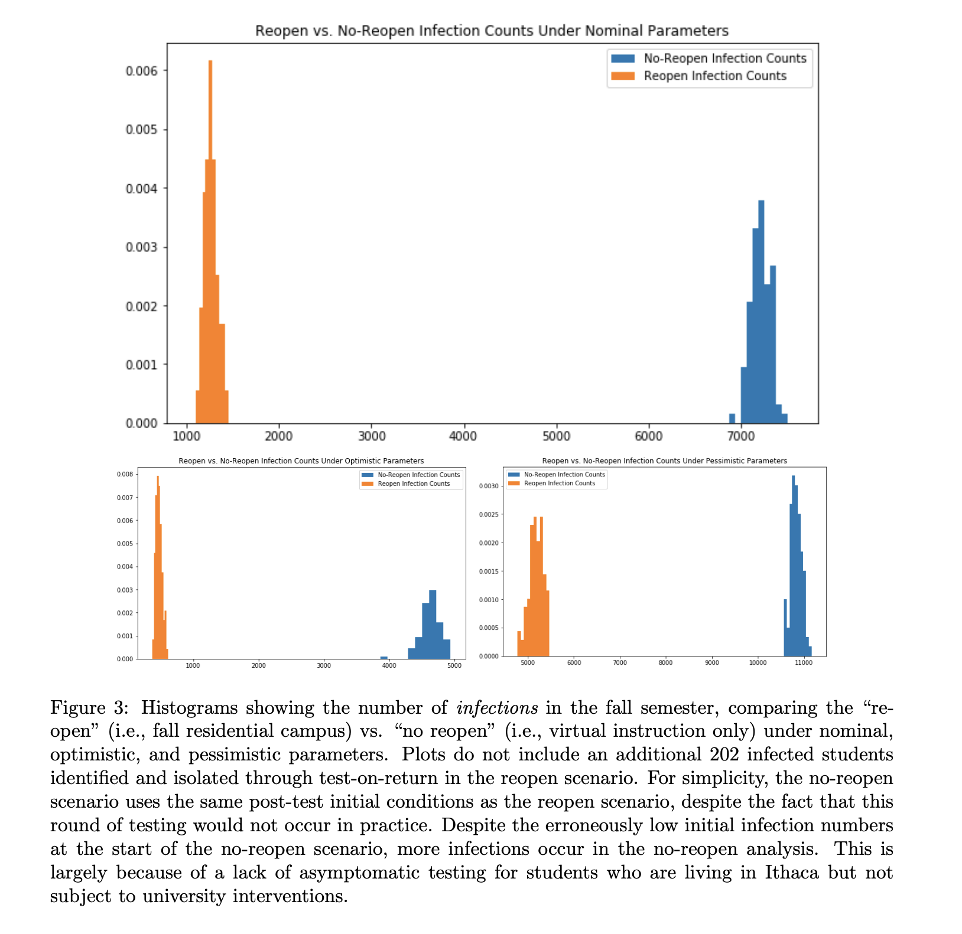
Example Peer Review:
What questions does the project propose to answer? [at least 2 sentences]
How many infections and hospitalizations will there be if Cornell stays closed for residential instruction? How many if Cornell reopens? How does this depend on the frequency of testing?
Is the question interesting and important? Why? Who will be most interested in the answer to this question? How will knowing the answer improve their lives, e.g., will it improve the quality of a decision they need to make? [at least 2 sentences]
The question is important and interesting to administrators at Cornell because it will help them decide whether to reopen and what mitigations to have in place. It is also important and interesting to students, employees, and community members because they would like to know whether they will be safe and they would like to know whether the interventions in place (e.g., testing), which are sometimes inconvenient, are necessary.
What challenges might the team may face in using the dataset to answer the questions they propose? [at least 1 sentence]
There are many important quantities that the team needs in their simulation but that aren’t available in their dataset. This will require them to guess about these quantities, which may reduce the accuracy of their results.
What is the visualization showing? [at least 1 sentence]
The visualization shows histograms of the number of COVID-19 infections anticipated if Cornell stays closed (in blue) and if they reopen (in orange). This is shown for three different sets of parameters. These sets of parameters correspond to different assumptions about reality.
What insight does this visualization give into the question(s)? [at least 1 sentence]
The visualization shows that the number of infections anticipated if Cornell stays closed is actually larger than if they reopen. This is because reopening will allow them to mandate testing.
Visualization and Discussion: What is good about it? [at least 1 sentence]
Using histograms allows the visualization to give a sense for the uncertainty involved. The discussion clearly explains what the histograms are showing and how to interpret them. The executive review of the report focuses on takeaways for stakeholders without requiring them to have a technical background.
Visualization and Discussion: What could be improved? [at least 1 sentence]
It is hard for readers to look at all three histograms, which show different assumptions about parameters, and understand them all together. Perhaps the data could have been put into one plot instead of 3, representing each histogram as a point with the number of infections resulting from re-opening on the y-axis and the number from not reopening on the x-axis. Instead of a histogram, uncertainty could have been shown with error bars.

Rubric for Project Milestone 2
Project milestone 2 will be graded by the TAs based on the following criteria:
- Dataset and Question: [20 points overall]
  - Make it clear to someone who is not familiar with the dataset what information it provides [5 points].
    - Is the dataset clearly described? You should give the source of the data as this can influence how it is interpreted.
    - Is it clear what indexes the records?
    - Are the columns described (or, if there are too many columns to describe individually, are the key columns used to conduct the analysis described)?
    - Sometimes the way in which the dataset was collected influences how analysis results should be interpreted – for example, when studying how nutrition influences health outcomes, surveys tend to underreport calories consumed while other data collection methods may be less biased. Also, if you cleaned the data or created it by joining multiple sources, this should be discussed.
    - If relevant, does the report describe aspects of data collection that should influence interpretation of analysis results.
    - Are there important limitations of the dataset or does it have any significant biases? If so, discuss this.
  - Does the project discuss at least one question? Does the project discuss the general goal of the data analysis? Is there a group of people that care about the answer to the questions? Does the report explain why this group should care? [15 points]
- Data analysis [50 points overall]
  - Recall that data analysis tools that are available for use in the class include:
    - linear regression
    - testing the assumptions of linear regression
    - investigating & dealing with collinearity, e.g., by dropping or residualizing collinear covariates
    - logistic regression
    - large language models
    - selecting a statistical model for a prediction task based on train/test splits
    - optimization via random search
    - controlling for confounders to demonstrate a causal relationship (make sure to also call out the limitations of your analysis)
    - simulation
    - building a new mechanistic model of a problem
    - A/B testing
    - A new method: You can also use methods that we did not cover in ORIE 3120 but are of a comparable or greater level of sophistication. If you do this, please make sure you explain why the new method is providing something that a method in ORIE 3120 cannot provide and also make sure that you explain the method and outputs clearly. Be careful – you will be judged on correctness as described below, including whether the new method is appropriate, and whether you understand how to interpret the results.

  - Flow, Does the Analysis Answer the Question(s): Is there a logical flow between the sections of the report? Do the data analysis methods presented collectively provide insights that answer the question(s)? If so, are descriptions of the insights and how they relate to the question easy for the reader to find and understand? [5 points]
  - Recall that project milestone 2 requires you to apply at least 3 data analysis methods learned in class. For each of these 3 analysis methods, we will grade according to the following rubric. If there are more than 3 analysis methods, we’ll take the 3 best ones. Note that these required analysis methods may be additionally supported by visualizations or tables or other investigations that support the insights provided by the analysis.
    - Insight: Are the results from the analysis reported in the report through writing, tables, and/or visualizations? Does the analysis give insight into at least one question? What is the depth of the insight offered? Obvious “insights” are much less deep. [5 points]
    - Clarity: Is the manner in which the analysis was conducted clearly described? Is the data analysis and the way in which it gives insight clearly explained and discussed? Insight can be given through written description, visualizations, tables, or any combination of these. [5 points]
    - Correctness: Is the analysis correctly applied and appropriate for the setting where it is applied? Does the report explain why the analysis method is appropriate? It is not necessary to use difficult methods to get full points — an easy method that is appropriate for the question and gives deep insights is just as good as a complex method. [5 points]
      - Emphasize that the report must explain why the analysis method is appropriate. This is especially important if you use a technique from outside the class (see the footnote for extra information if you choose to do so.)
- Quality, clarity, and organization of the report [15 points total]
  - Is the language of the reports used in a clear way, without typos that influence the reading? [5 points]
  - Is the report well-structured? Does it have a good flow within paragraphs and within different sections? [5 points]
  - Are the graphs and model output clear? For example, a graph without labels is usually not clear because the viewer has trouble knowing what the graph is showing. [5 points]
DOs & DON’Ts for PM2
To help give more context about the above rubric, we offer the following list of DOs & DON’Ts.
- DO: Make sure that your introduction is good. This is an appropriate place to summarize what your questions are, why they are interesting and important, and who cares about them and why. It is also a good place to summarize your answers to the questions and any significant limitations. If your stakeholder (the person who should care about the questions) reads this introduction, they should be excited about reading the rest of your report.
- DO: Make sure your question is actually interesting and that you explain why. If the answer to your question is completely obvious, then it isn’t interesting. If there is a person in the world who would invest significantly (for them) in hearing your answer, then it is interesting.
- DO: When reporting results from analysis (i.e., r^2 or p value) you should explain how to interpret the technical values, and why these results matter. This should be interpretable by the audience stakeholder, and should not depend on advanced technical knowledge.
- DON’T: reteach the course. For instance, you don’t need to explain linear regression, the internals of coding syntax, or how a computer chip works. For example, you could say you cleaned the data and then chose to use linear regression and why, but you don’t need to convey the theory or details behind it to someone who isn’t familiar.
- DO: ensure non-technical stakeholder reads the report and thinks this is very valuable, and I’m going to change what I’m doing!
  - Example: The p-values are… In other words… (example from one of Allison’s works): "In the case of health care plans, there is a statistically significant relationship between reports of adequacy and stipend amounts (p < .0001). The relationship between the adequacy of leave policies and stipend amounts is also statistically significant (p = .01). In other words, GSIs who are struggling to make ends meet with their stipends also face higher barriers in accessing healthcare."
- DON’T: have it be at a state where a data scientist would read the report and think “I don’t trust these results because I can’t tell what they’re doing or why they’re doing it.”
  - Putting technical details in the appendix: if an expert reader would be suspicious if they didn’t see it, then make sure it is in the real report. Otherwise, if it’s more extra do put in the appendix.

There will be 1 regrade point on project milestone 2.
For most teams, all team members will earn the same grade on PM1 and PM2. If there is a team, however, in which one or more members did very little work, those team member(s) who did very little will earn fewer points.

Use of ChatGPT
You can use ChatGPT to help you generate ideas and refine writing but asking ChatGPT to write large sections of text in an unsupervised way will typically result in a low grade. ChatGPT typically produces low quality output that looks pretty good at first glance but has conceptual errors and lacks insight. If a job candidate’s ability to deliver business value is comparable to what ChatGPT can deliver, then why would a manager hire the candidate? To be competitive in the modern workplace, you need to significantly outperform ChatGPT. Grading in ORIE3120 reflects this reality.

Example Good Reports
- Examples of project milestone 1 & 2 from previous years with discussion of one of the reports.
  - One note — the report studying the Olympic medal dataset is good overall, but it should have done a better job of describing the dataset.
- Cornell epidemiological modeling reports. These reports were written with an audience in mind of Cornell students, staff, faculty, & administrators.
  - Classroom transmission analysis: Uses Cornell COVID-19 Surveillance data, logistic regression, and causality to answer the question, “Does being enrolled in a class with a COVID-positive student increase your chance of catching COVID when masks are mandatory in classrooms?”
  - Booster Effectiveness: Uses the same data & techniques (logistic regression & causality) to answer the question, “How much does getting a booster vaccination reduce your chance of getting COVID?”
  - Fall 2020 Modeling Analysis: Uses simulation (which we’ll learn later in the course) to answer the question “Should Cornell offer in-person instruction or only virtual instruction in the Fall 2020 semester?”

Things to Avoid
- A common pitfall on Milestone 1 is asking an easy-to-answer question like, “What is the average of this field?”, or “Which categorical value maximizes this feature?” without articulating a good reason why the answer to this question would be interesting to someone.
- Trying to satisfy the criteria for Milestone 1 by creating a visualization that doesn’t connect to something that matters. For example, creating a map showing the # of 911 calls by zip code, without explaining why this matters. To make this better, a report would connect it to a question that matters. Step 1 would be to come up with some questions that someone cares about, such as:
  - How can we organize our emergency medical services to save more lives? The director of the fire department would care about this. The mayor might care.
Step 2 would be to present the data in a way that can help to answer the question, like adding a second map that shows the fraction of calls that are answered on time. This helps to answer the question because we would want to direct resources towards places that have a lot of calls and don’t answer many on time. Or, adding a visualization that shows when the calls happen, so that we can figure out how to staff our shifts with emergency medical technicians.

